**Post last 72 (Line - 912149)**

**URL : <https://i.redd.it/cycb2djsd1l81.jpg>**

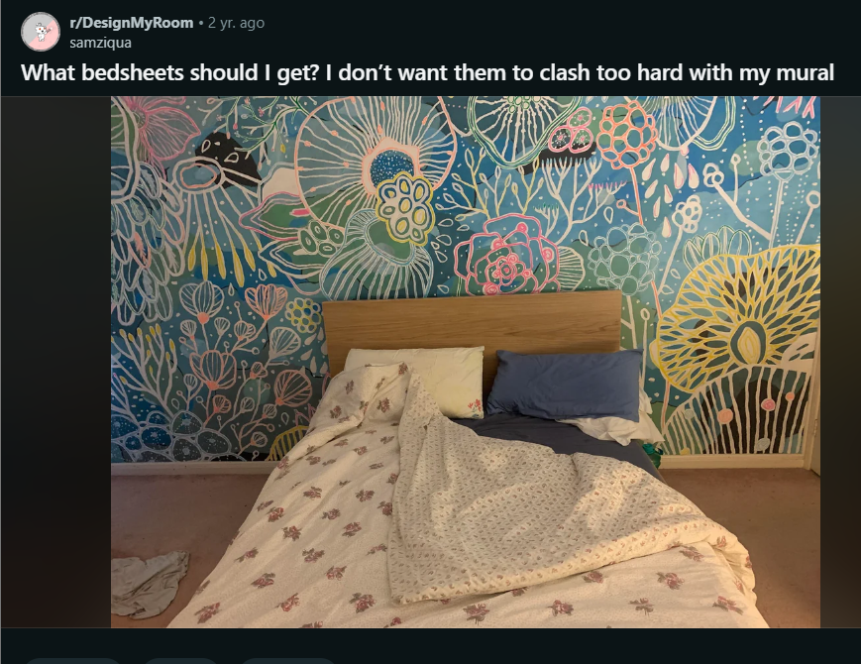

**Comments :**

1. I\u2019d get a solid colored pink and maybe green or yellow pillows with it but that\u2019s just me!
2. totally! solid and a few colors seems like the safest and best bet. buy two or three sets of sheets and mix/match
3. 100% this. Solid sheets, solid comforter
4. I would try for cream coloured sheets and comforter (basic, no pattern) with some pink and lime/yellow accent pillows.\n\nETA - love the mural by the way!
5. I\u2019m a big proponent of all white sheets (bed sheet, duvet cover, pillow cases), so you can bleach them while washing, and accent throw pillows and blanket(s) on top. I\u2019d go with soft blue pink and yellow tones for those.
6. Seconding this, you can also get white sheets and comforter with just a thin blue piping around, it\u2019ll really tie the room together
7. So far I\u2019m liking the blue.  Teal would be good too, chambray or mixed blues.  \n\nAdd an accent pillow if you like but keep most of the bedding a background color so focus remains on the mural.
8. I was really hoping that was wallpaper because I LOVE it.
9. Cream/terra cotta pink. I\u2019d definitely not involve another pattern, the beautiful mural does so much work making the place special.
10. I'd go with white/cream for sheets/duvet and accent with pillow colors + throw blanket color from the mural. I think going with a dark color for your bedspread would be very overwhelming.
11. I personally would go with a darker blue to match one the blue colors of the mural or match a lighter blue from the mural. I think if you go with another color like yellow or white your eyes go to the bed first whereas I would want the mural to be my feature. I'd definitely add on colorful throw pillows though like the peachy orange, pink, yellow, etc so the bed still pops.
12. i think a light blue solid linen duvet with a little fabric texture to match the walls without overpowering it. And then, maybe similar colored sheets and/or light pink or citron to switch it up \u00af\\_(\u30c4)_/\u00af \nBEAUTIFUL mural though, you painted it yourself?!
13. Yellow with darker pillows
14. Cream or light pink
15. I\u2019d go with a plain pale yellow
16. Move all the furniture out of the room so you can stare at the masterpiece all day\n\nSeriously though I dream of owning a home one day so I can paint fun murals on the walls.
17. Omg that mural! \ud83e\udd70\ud83e\udd70\ud83e\udd70\ud83e\udd70\ud83e\udd70
18. Baby blue baby
19. Clearly you love color, so embrace it! I\u2019d pick one of the mural accent colors (pink, yellow, green, etc.) for a comforter, another for your sheets and a combo of all (with accents of blue) on throw pillows. You can have so much fun with this, and should!\n\nedit: comma
20. You could really lean-in to the maximalism here.  A vibrant large floral print would look amazing.
21. The mural is quite marine so maybe like a raw linen green or earthy colour style to make the bed feel like your own island in the water. Or light blue to make it your 'safe bubble'. Pink would work quite nicely too, a nice dry sandy warm pink colour.
22. You\u2019re saying someone painted that and it\u2019s not wall paper??? Gorgeous!
23. I'd honestly just do plain white
24. I'm with everyone who says solid colors. You could bring down any of the colors from the mural, but go lighter. A pale pink or yellow would highlight the mural.
25. Wow! What a beautiful mural!! And I understand you painted it yourself. That\u2019s awesome. \n\nI would go with a very tailored linen retro bedspread with pleats in the corners - in a vivid green or pale yellow. Add a Greek key piping/trim in a contrasting color (bright pink or white). Do the sheets in solid pastel colors that match the background: pink, pale blue, off-white, cream, spring green, maybe some black polka dots on a beige background.\n\nHere\u2019s an idea:\n\nFor the total maximalist\u2014\n\n[URL]\n\nPlush Kelly Green:\n\n[URL]\n\nKhaki:\n\n[URL]\n\nSolids available in queen size; Succulent, Blue, or Pastel Pink:\n\n[URL]
26. All white/ivory/very light gray would be nice and it would pair nicely with your headboard too!
27. I know this sounds weird but I'd try a Coffee berry color.  Match the vibrancy in the color.  Use a solid.  Try not to match a color in the wallpaper.
28. I\u2019m feeling [this ]([URL] texture in the blue color
29. They should all be different colors,  and each color should be in the mural.  I'm seeing turquoise fitted sheet,  apricot flat sheet,  a mustard pillowcase and maybe a lavender one too
30. I\u2019d do copper / rust / brown solid earthy sheets :)
31. Neutral stripes or polka dots
32. A light/bright green to match or if would be cool if you could find some white sheets with thin stripes in a color on the wall
33. Plain light yellow or plain light green (same shade as on the mural).
34. Lovely mural. I Wud try dark blue w/o pattern
35. There are two pinks in your mural.  I would go with the lighter of the two, the super pale pink, and get some lovely rumpled linen sheets with a matching duvet. Something with a lot of texture, like [this]([URL]
36. already agree with the top comments, can't go wrong with a solid color really. Just need to comment how much I love that mural! So cool! Did you do it yourself?
37. Voting for plain yellow bedding like that big flower on the right, maybe with some pink or light green accents (like in the mural). The wall is very blue already very blue so I wouldn't go for blue sheets.
38. simply monotone - white, dark blue, dark green - up to you. I always vote for monotone bedding. It makes interior look really expensive
39. I\u2019d go with the green. It\u2019ll be subtle.
40. Solids only.  But use various colors on the bed at the same time that match the wall. Accent pillows could have some patterns so as not to compete with the wall
41. More subtle:\n\nPick one the \"background\" blues from the mural for the bedsheets/duvet. Get pillows and throws in the other colours.\n\nIf you wanna be not subtle at all, reverse! Get one of the other colours for the sheets (I lean yellow) and get blue and pink accessories.

**Post last 73 (Line - 911615)**

**URL : <https://i.redd.it/5gdqtzhl5op91.jpg>**

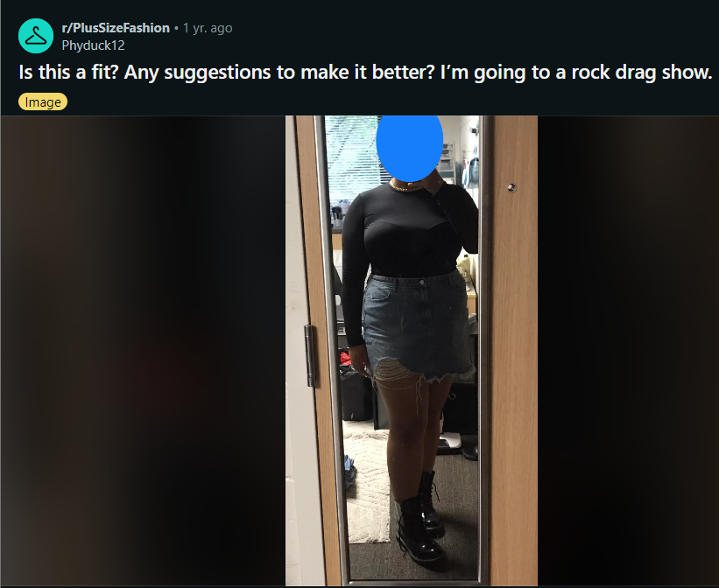

Comments :

1. You look so fabulous! Maybe play with some layered necklaces? A short, medium, and long chain?
2. Yes! Some chains with this would complete it.....maybe some bangles?
3. Yes! Glam makeup would be the icing on the cake. Maybe some gold eyeliner?
4. Fishnets or a chain belt :)
5. It's a fit! If you have a gold bracelet I think that would really compliment the bottom half of the outfit to that gorgeous necklace!
6. As others mentioned, fishnets! Maybe some statement earrings or bold makeup. Otherwise, this is definitely a fit!
7. I say glitter tights
8. Belts.  Jewelry.
9. You look amazing! I would add a gold chain belt if you could find one.
10. I feel like you need more bling. The outfit is fine, but it looks a but drab. You need somethings to make you pop. Maybe a print belt? Some waist chains?
11. Girl! You gotta define that waist with a belt! If you\u2019re going gold necklaces like the other suggestions I think a gold belt will kill.
12. It\u2019s great. I\u2019d layer more jewellery (silver necklaces) and maybe add a leather or jean jacket, weather dependant

**Post last 74 (Line - 911359)**

**URL : <https://i.redd.it/aaioquy81d781.jpg>**

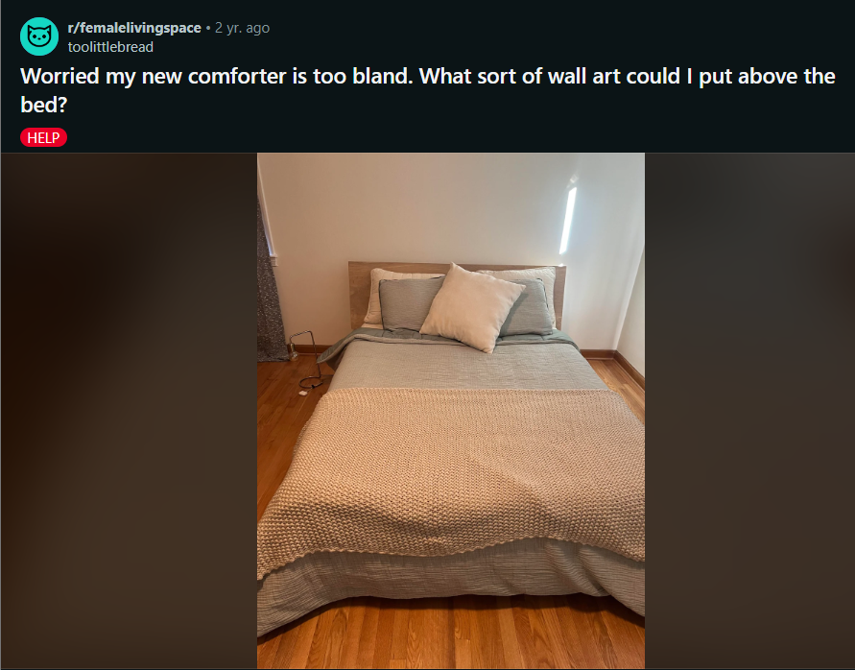

Comments :

1. You could do a fun patterned rug too!!
2. I totally love the plain though. It's calm and neutral, a perfect way for a bedroom to be.
3. It's really nice.  Get some art on the walls, a rug, night stands, decorative pillows, - take your time it will all come together.   \n\nI'd go with a simple large canvas print of something that you find calming.  Beach scene, abstract, garden, flowers, whatever.
4. I have a brown faux fur throw on my all-white bed (the West Elm one) and it makes a huge difference!
5. I would fold the blanket one more time and lay it across the foot of the bed but not over the edge of the bed, that will make it look more plush.
6. Macrame! it looks like you have good light for a few plants as well :)
7. I would swap out the throw for one with color, same with the pillow, I'd add a plant to the room as well. For the wall art I'd either do one large one or 3 smaller ones and make sure the pop of color from the throw is in the art. Those are my suggestions because the room is giving a cold look
8. We\u2019ve used Tempaper Peel & Stick wallpaper before and it reallllly makes a room pop! Comes off super easy and clean too. If you don\u2019t find wall art that works for you, you should check out some of their wallpaper designs!
9. Everything I was thinking has already been mentioned except for one thing - get a nice floor lamp
10. Add some navy and orange  to your bed.
11. I would get an area rug before getting wall art!
12. A landscape that has some of the gray and beige.  Or a textured wall hanging.
13. i\u2019ve personally planning to buy [this]([URL] wall art & i think a nice fluffy rug in your favorite color (but a light version like pastel pink) would spice it up a bit. maybe even some fake plants on a bedside table would give it a nice pop of color & personality.

**Post last 75 (Line - 911154)**

**URL : <https://i.redd.it/00f3dqbcq3291.jpg>**

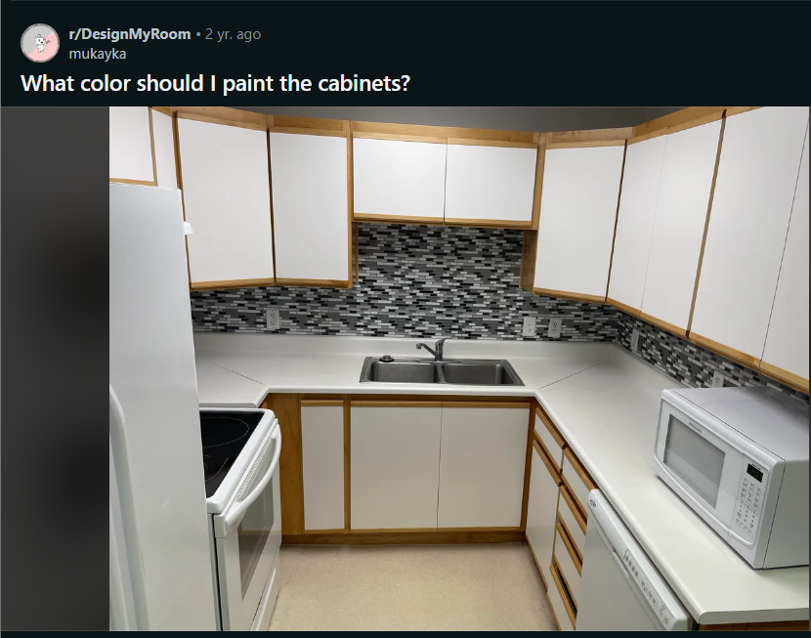

Comments :

1. Anything you paint this will immediately make the room feel smaller and darker than it does with white. Also, the palette is tough between the backsplash and the floors which really do not work together. Would you consider leaving the cabinets two-toned and painting the wooden parts a charcoal grey or black? If you do paint the full cabinets, perhaps a blush pink would work, but I would investigate changing the floors first. A brighter floor in the backsplash scheme would give you many more options.
2. I\u2019d leave the cabinets and redo the backsplash.
3. This style of cabinet often has a Formica type surface.  I imagine they will be really hard to paint. I agree with others that a lighter, warmer backsplash would be nice.
4. Paint the wood part white and add black knobs/pulls. That will make a big difference. The 2 tone make it dated
5. I agree, also change the flooring to grey to match.
6. Maybe the lightest grey from the backsplash.
7. Painting melamine is a huge undertaking and an even bigger headache. It\u2019s not like painting wood cabinets, they require more prep work and are unforgiving when it comes to even the tiniest mistakes. If you do decide to paint, I\u2019d have it done professionally by someone with melamine experience. And the blush color suggested for cabinets is a great choice.\n\nI agree with the others, new flooring, paint the trim charcoal grey (not black, too harsh) and get rid of the backsplash , bring in new appliances (a microwave over the stove will free up much needed counter space) and you will be happy with the money you saved by not painting.
8. What if you paint the wood parts of the cabinets white?
9. There is a process you have to go thru to resurface cabinets, you can't just paint them or the paint will chip off. All supplies are available at Home Depot. I have the same cupboards @ my cottage; I painted them Powered Snow (a perfect shade of white). You have to take all the doors off & the drawers out. I would keep them white but I would eliminate the brown & add hardware (door pulls & knobs) to them. It will make them look a lot better.
10. I think light gray, or a light green gray would look good. Handles will elevate everything if you choose wisely.
11. Get 3 test colors and paint them on cabinets. I think grey would drown the kitchen I\u2019d try a sage or pistachio or maybe a creamy yellow.

**Post last 76 (Line - 910940)**

**URL : <https://i.redd.it/v3el9ezimqx41.jpg>**

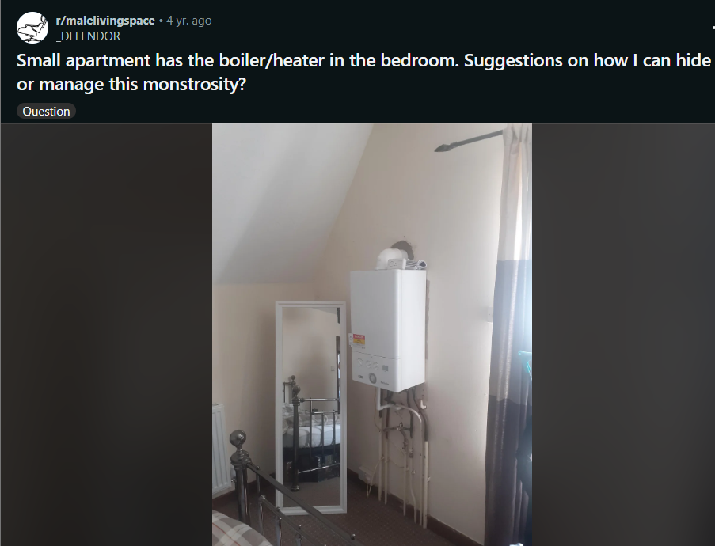

Comments :

1. Cheap IKEA wardrobe, modify the back and slide it over it.
2. I'd say take the back off a wardrobe and slide it back. Be careful it doesn't get hot in there though!
3. Plants, depending upon how hot it gets. A tapestry, or some other kind of art. Or one of those privacy screens. Like, the room divider things with multiple hinged sections.
4. Since it\u2019s likely a rental and you might not want to modify furniture for it, I\u2019d just get a table and put plants on it.
5. Ehhhhh do you really need the boiler/heater ? Hammer it out  and call it a day *shrugs*
6. Try a room divider or large standing mirror
7. Of course this is the UK. London I presume?

**Post last 77 (Line - 910743)**

**URL : <https://i.redd.it/gqss9vmuuhc81.jpg>**

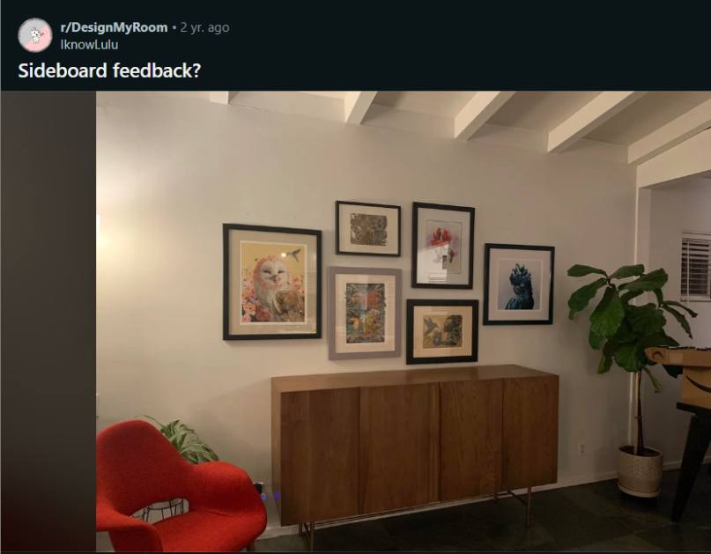

Comments :

1. I second the lower and longer suggestion! But the color of it is perfect, and everything else is perfect! Like seriously, the colors and the vibe and the different textures\u2026just beautiful. And the artwork is AMAZING
2. It\u2019s a pretty piece, but lower and longer would be better here. Love the art and layout!
3. Yes go lower, the top of the sideboards needs more space from the bottom of your gallery wall
4. That owl looks so smug and I'm here for it! He knows something you don't.\n\nPersonally I would have wanted a slightly longer sideboard, but it definitely works!
5. Lower and longer so the art doesn't go beyond the piece.
6. The art isn't that wide but it's not wide enough to be most of the wall and it's not close enough to fit over the sideboard.  \n\nI agree that by itself it looks great.  But since the sideboard is shorter it feels a little bit like toes that hang over the front of a sandal.\n\nI would look for a single sideboard about a foot longer.

**Post last 78 (Line - 910573)**

**URL : <https://i.redd.it/nex59nwb5r561.jpg>**

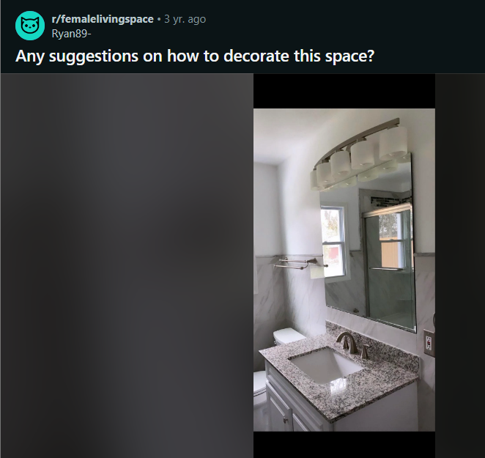

Comments :

1. It feels really sterile- I\u2019d love to see some real or even fake flowers in yellow or pink somewhere!
2. Agreed. Needs something to warm it up.  A succulent on top of toilet maybe. Fresh yellow towels. Those hexagon shelf things would be neat. Can put some fake greenery in there. \n\nIf you are any way handy, maybe a wood trim around the mirror (if you cannot fully remove the mirror).
3. Pick a color scheme. The bath mat and towels should all be the same or a similar color. Any other accessories (toothbrush holder, soap dispenser) should fit in with the scheme but they don\u2019t have to be matchy matchy.\n\nA few framed prints (less is more) will liven the walls up a little. Bathrooms are also great for growing plants such as ferns and orchids, because they don\u2019t need much light but love humidity. \n\nScented objects such as candles and diffusers are a great idea. A little basket on the top of the toilet with hygiene products will also be nice. You should also have a trash bin with a lid.
4. I think a pop of color. Can you paint the wall?  Something to contrast with gray.   Some nice red towels on the rail and accessories by the basin. I would put a hanging plant near the window rather than on the toilet.
5. Just add some color with flowers and towels and I think it would look great. Any color would work.
6. How you decorate really depends on your personal taste but simple things that will make a difference are your hand towels and bath mats - they don't have to be super matchy imo, as long as they're in the same family (e.g. grey bathmats+white towels). Having a hand soap and lotion set (especially if this is the bathroom guests will use) will make the space look more put together as well.\nPlants can help - I personally lean to larger trailing plants like pothos, which don't require as much care or sunlight and thrive in humidity.\nAlso, don't be afraid to change fixtures or door knobs if they're not to your taste!
7. Keep it simple! Add towels and either two floating shelves that are at different levels over the toilet or one framed piece of art-\nI\u2019d go with a black and white abstract and then have the color in here be the towels.

**Post last 79 (Line - 910273)**

**URL : <https://i.redd.it/ffy7bejgkvi61.jpg>**

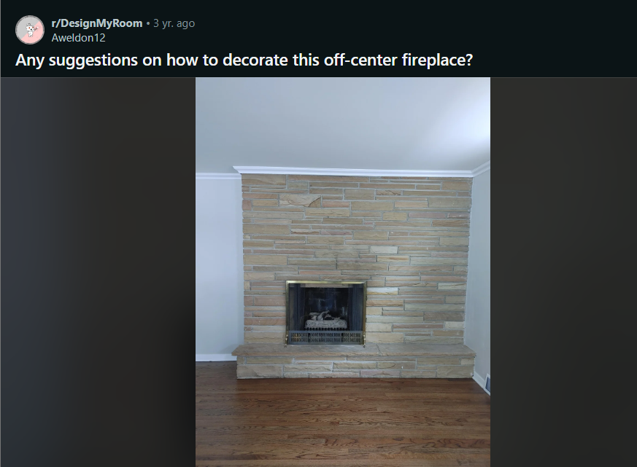

Comments :

1. Very cool! I would do floating shelves on the right and a big piece of art over the actual fireplace
2. Probably 3-4 but you\u2019d have to play with the spacing. I\u2019d put the lowest at the halfway point of the fireplace. I can\u2019t tell if you\u2019re fireplace is truly wood burning but I think some logs in a basket directly under the shelves would be very cozy.
3. You could put a floating mantel across the entire space and add a wood storage rack beside the fireplace to balance it out. I would place any large art over the center of the space if you go with this approach. Or have multiple pieces that spread further out instead of one main piece.
4. I think a blanket ladder could also work here! Then maybe a simple mantle over the fireplace and art or a mirror above it
5. It might be cool looking to stack chopped wood up to the ceiling?
6. A floating mantle almost the length of the wall in order to hang one large art piece to the left with medium size accessories (candlesticks, jars,) greenery, or 1-2 medium and 2-3 smaller pics on left. I see soot builds up directly over fp so anything that can be wiped clean gives over fp. Large basket to hold firewood to left along with two pillows in corner and fp acccessories to right with more greenery
7. Love the stone! With the art, you could look for something with warm pink and orange tones to pull out some of those colors. Are you planning to keep the brass framing around the fireplace?
8. I don't think you need to do anything too statement-making! There's something about that particular finish on metal that I've just never liked, but I could actually see a more [modern version of a brass frame]([URL] looking cool...
9. This is a lovely mcm fireplace that doesn't need, or want, a mantel or shelves.  Let the stone and fireplace be a focal point without detracting from it.  It was meant to be bare.\n\nBy all means add some mcm fireplace tools and a log holder...you could add couple of amazing tall vases to the right, but that's all it needs.
10. You could do something organic, like a floor vase with some cattails or pampas grass in it...
11. You can hang a piece of [big wall art]([URL] above the fireplace
12. Wow. Do you have the means to extend it longer to the left. Or do away with it. You can prob easily demolish it and sheet rock that area.

**Post last 80 (Line - 910127) --> Deleted**

**URL : <https://i.redd.it/h76x3jk3zh241.jpg>**

**Post last 81 (Line - 909362)**

**URL : <https://i.redd.it/oj4wn5rnuke21.jpg>**

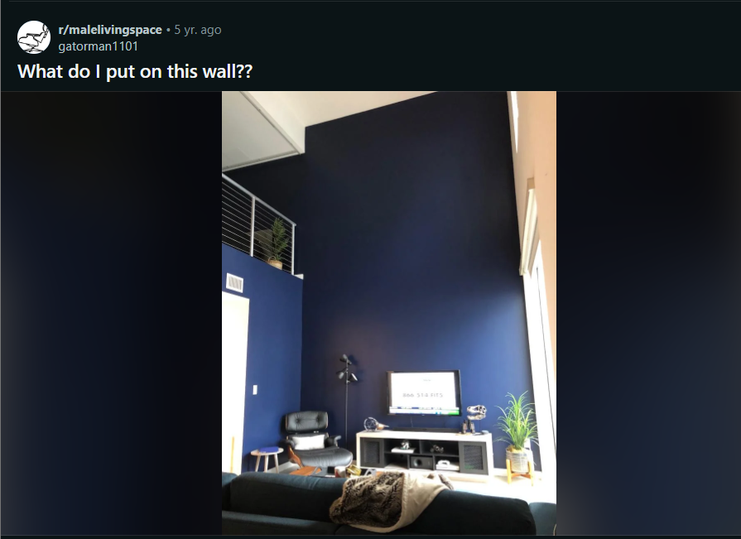

Comments:

1. A massive indoor waterfall would be a nice, simple touch
2. a formula 1 car bolted to the wall. check your lease to see if your landlord is okay with that.
3. [Was about to say the same with this picture from the NYC Museum of Modern Art.]([URL])
4. A big, portrait mode (vertical) abstract painting would look good imo. A huge black and white photograph could look good too. Or maybe some kind of large tapestry? You could also leave it blank since the blue on its own looks good too.
5. Honestly nothing. That deep blue wall is purely magestic
6. Yeah I like it how it is. It\u2019s easy to go overboard and do too much.
7. Climbing Wall
8. I feel like you are somebody that could totally rock some Egyptian wall decor like [this]([URL]
9. Scale map of Westeros.
10. [Terry Crews]([URL]
11. Excellent, I was looking for a new painting for my mantle.
12. I had a loft like this once. Got 2 giant canvases from the art shop downtown (rented a uhaul to get them home)  and a color wheel, picked a couple of shades of coral and grey paint at home depot, (teal walls, grey couch), and went to town with brushes, rags, and rollers, doing a jackson pollock sort of nonsense to them.\n\nThen I hung them vertically to fill up the wall. people asked who the artist was ALL the time, and the colors brought all the walls and furniture together. I was sad when I moved into a place in which they wouldn\u2019t fit, or i would have ghosted them and repainted. \n\nCost me a few hundred bucks in canvas, but if your chair is authentic, I imagine it wouldn\u2019t break the bank.
13. Nice suggestion. Two smaller custom made pieces with simple geometric or abstract design.\n\n&#x200B;\n\n[[URL]
14. Ultra short throw projector
15. Get some pothos vining down the wall!
16. huge abstract art piece.
17. A black and white map with accented blue locations of importance or main city names
18. Get a bigger version of that t Rex skull and hang it. \n\nTell people you killed it on Isla Sorna
19. projector screen
20. Hanging Ivy wall and a larger, higher mounted TV
21. I have a nice, high wall like this in my house.  I have resisted the temptation to put art on it, and I reconsider every year or so, and every time I end up just really liking the big, high wall with nothing on it.
22. some small stars in the shape of your favorite constellation, minimalist but can take up most of the wall space...it will mostly be a blank wall, but with a handful of stars, maybe made of a reflective type material.  Maybe get a projector so you can get the layout right.
23. Some huge yellow painting
24. A big ger TV!
25. IKEA logo
26. Maybe some plants on shelves or a painting.  Just a suggestion.
27. I would make a photowall or perhaps put up your skis/bike. Large objects that normally would be hidden in storage. I think it makes a nice contrast.
28. You could purchase a few tapestries that would look good together. Like one stacked on top of the other vertically. Tapestries from urban are like $60 each and take up a lot of space.
29. A map of some sort.
30. Beautiful PopArt.
31. A flag or maybe just have some shelves set up and place some displayable-s in there
32. Could do an interesting wallpaper.

**Post Last 82 (Line - 909127)**

**URL : <https://i.redd.it/651ggutb7mq81.jpg>**

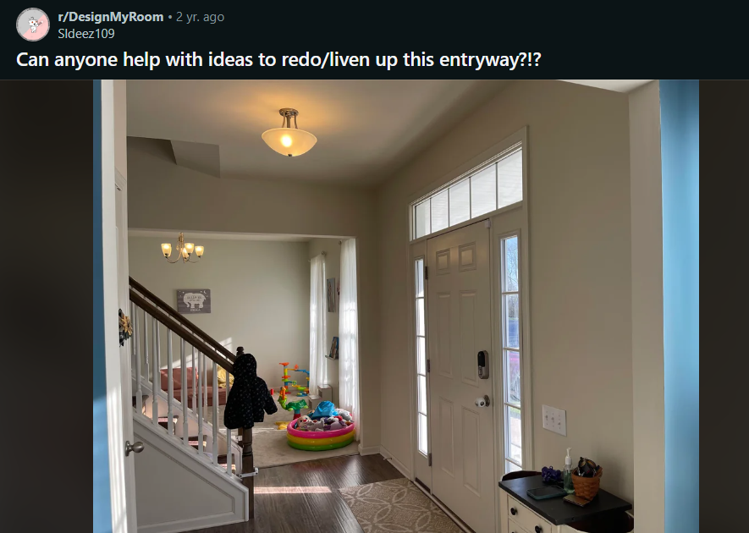

Comments :

1. A more \"statement\" lighting fixture could add some visual interest, as could painting the inside of the front door. Lovely space!
2. THIS. That light fixture is screaming to be better haha. And painting the door would do a lot. I would love to see more contrast in this space so something dark (deep grey or black) would look really good. If that's a little too bold I also think a light sage green or or warm toned light grey would look nice.
3. Also a mirror above the credenza
4. Rug that makes a bigger statement (even a longer runner to include the side lights and walls on either sides of the door. Art on both sides of the door that coordinates with the rug
5. What about family portraits on the wall where the entrance door is, or cute family slogans next to the white cabinet. I think these two concepts are simple, try not to over clutter the area too much. Hobby Lobby has great options to choose from. [Wall Decor Idea 1]([URL]
6. Paint the inside of the door black. Wallpaper or accent color on the same wall as the door with a rug that ties in the pattern or color. A plant or something on the other side of the door to balance the side table on the right. As someone else said, a more dramatic light fixture would be nice.
7. That would be a lot of work and I would do that last. If you like it without the black trim I would keep it white as it is really hard to go back to white after black. I kind of visualized a black and white wallpaper, but even with color the white trim provides contrast. I am big on contrast but non-white trim is trending right now so black trim is an option for sure.
8. "I too believe you need a bigger (statement feature) light fixture, still keep it semi flushmount. Larger rug. Coordinating rug for the stairs. Large art to the left of the door. Mirror over  cabinet.  Paint walls med tone of blue or green, whatever you prefer.
9. A large mirror, a tall plant.
10. How about painting that door and window also blue like the walls you already have? Add a doormat with that color scheme and a new light and it will look stunning. Very nice already actually. Example of a [lamp]([URL] and [door mat]([URL]

**Post last 83 (LIne - 908937) --> Deleted**

**URL : <https://i.redd.it/xzbxycw1do741.jpg>**

**Post last 84 (Line - 908618)**

**URL : <https://i.redd.it/dz3p3in3bvj91.jpg>**

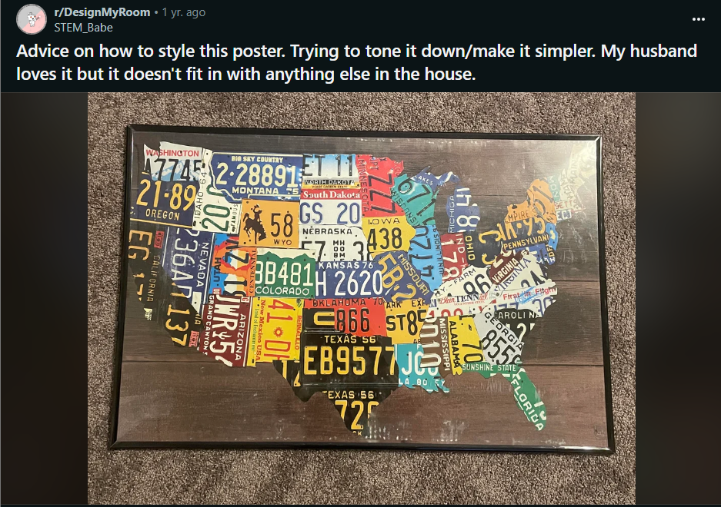

Comments :

1. Get it matted and properly framed. This will make it look like an art piece.
2. This is a famous installation at the Smithsonian Folk Art Museum. \n\nI\u2019d look for another version of the poster. In real life, it\u2019s mounted on a white wall. The background is making it look rustic.\n\nETA: The preamble to the Constitution is at the Smithsonian. Wrong license plate art. I can swear that I\u2019ve seen this on a different background.
3. Have it at your entry above a rack for car keys. Bam!
4. How crafty are you? Because I think cutting out the map and posting it on a wooden block in the same shape would make this seem like a more intentional piece of art and not like a juvenile poster. Then you could hang if desired, but really you'd have more options for just placing it somewhere like on his desk (if he has one), maybe by his bedside table, or really just in a spot that's his around the house.
5. Man cave it. I think it\u2019s charming with so many different plates.",
6. Frame is small and mean looking.  A bigger thicker frame, probably brown but should match a colour in the image.  Add a mount of at least 15 cm/6 ins all the way round, so frame doesn't look as though it is crowding the picture.
7. Unless you convert it to B&W, nothing will tone this down. If it doesn't match your house but he still loves it, put it somewhere he's likely to be the only one to see it (ex: office, garage, man cave area, his favorite bathroom, etc.) and decorate that space around it to match it.
8. String highways
9. Cut it out and put it in between glass for a unique side or game table in the man cave. It won't be as \"in your face\" if it's not on the wall.
10. Probably a stupid idea, but you could try playing around with opaque or tinted window cling film over it to mute it a bit. Try it on the back of the glass first to see what it'd look like
11. I would cut out the outline of the us and mount it on white poster board with a lighter frame

**Post last 85 (Line - 908245 )**

**URL : <https://i.redd.it/xrezdnavh9l31.jpg>**

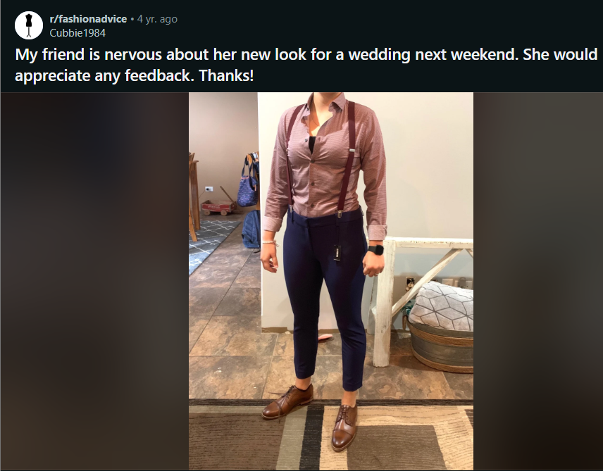

Comments :

1. You could roll the bottoms of the pants and wear with short boots
2. The mis match of colors is not great. The brown shoes and the mauve top are throwing me off! And the pants are way to tight, maybe if they were higher up on the waist it would be a bit better? I do like all of the pieces separately but together looks a bit messy!
3. On the right track. Seems a bit casual for a wedding, although if that's the point, then that's fine. Shoes and top colors clash. I would change the color on one of them. Top is a little tight around the bust. Make sure to put a safety pin in just in case the button comes loose.
4. Pants need to be a better fit, and longer so they meet the shoes
5. The tight crop/ankle pant is the thing now.. blows my mind that people actually want to wear them this way
6. I can understand a crop, but doesn\u2019t really look great with a men\u2019s style dress shoe imo
7. The only problem is that the pants look like leggings, which is too casual to match the rest of the outfit
8. Pants are way too tight
9. I might pair a jacket with this? It doesn\u2019t have to match the pants but I think it would elevate the outfit
10. Coming from a bisexual woman, I think this look is hot!  I agree with what the other commenters are saying, though: pants are too tight, too short and too blue.  Your friend would look fantastic in a more straight legged fit. x
11. This actually looks great! The brown of the shoe matches the suspenders and the navy / rust colour look really good together.
12. Thought it was a guy for a sec because of the clothes but it still looks really good.
13. Slacks would look better, something looser. It looks informal for a wedding, unless the wedding is informal.
14. Maybe consider a loosened tie instead of the suspenders. I would like to see the final outfit please.
15. Ya Look amazing! Hope you can feel comfortable inside and I see damn well five on outside !!celebrate the night away!

**Post Last 86 (Line - 907991)**

**URL : <https://i.redd.it/4vkxb9qk2ih71.jpg>**

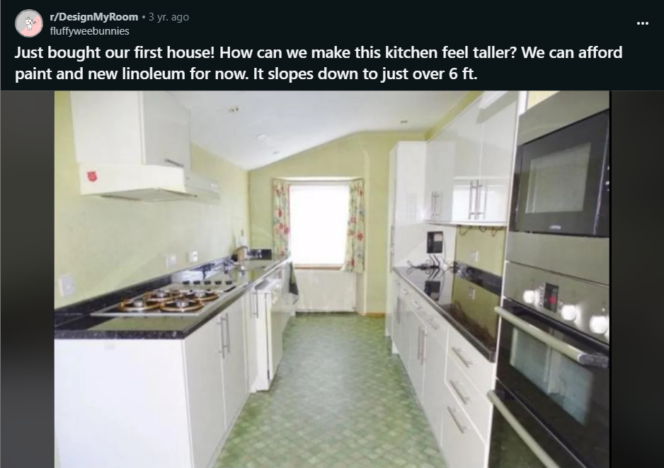

Comments :

1. Paint the walls and ceiling the same light color, so your eye is not drawn to the demarcation.   Maybe raise the curtain rod as high as you can (IF you want to keep curtains in your kitchen).
2. Yup this is a huge part of the answer. Your walls and ceiling should need to visually read as one surface.\n\nI'd also install some moulding to take the cabinets up to the ceiling. The empty space above them breaks up the vertical lines and makes the room feel shorter
3. What look are you going for? I think there\u2019s way too much green which is making it look smaller, white and gray on the back wall would help a lot, maybe with fake wood linoleum or a modern black and white tile pattern. Keeping it black and white will match the cabinets, which is nice for cost saving. \n\nLong term, you should add a backsplash. Stick on fake subway tiles are pretty cheap, but if you want something more permanent you could also just use a mixture of the white and gray to differentiate from the rest of the wall. I agree with other commenters about shelving above the stove side, matching cabinets could be a long term goal since open shelving is a PITA to keep neat. Since there\u2019s a gap from the top of the cabinets to the ceiling on the other side, you should have the cabinets start the same distance from the counter and get as close to the ceiling as you can get. \n\nFinally, this is just my personal style, but I think sloped rooms look really cool with exposed beams. You could totally fake a beam with a couple long pieces of wood nailed to the ceiling.
4. Look into some IKEA floating shelves on the short wall, to give it more vertical functionality. Style some of the shelves with vertical items: a tall painting leaning against the wall, a vase, etc. \n\n(I know you said this is out of budget, but I\u2019m not sure if paint and linoleum alone will solve your issue.)
5. I\u2019d be tempted to put a cupboard with a drainer above the sink/dishwasher area, so you don\u2019t notice the low ceiling so much, and you get a practical space to leave wet items to dry, out of sight. [drainer cupboard]([URL])
6. The curtain is chopping the height into 3 separate pieces. Get rid of it for instant results.
7. A light filtering blind would look nice and fade into the wall. Or a frosted film for an even sleeker look, if that's what you're going for.
8. White walls and ceiling,  Larger floor tiles [like this]([URL] it picks up the dark counter tops.  Remove the curtain.  I like [this galley style kitchen]([URL] where the wall at the end is a pale grey to draw the eye.
9. Paint the walls and ceiling white! Maybe consider doing the back wall with the window as an accent wall in a deep charcoal or dark dark blue. On the floors, you could do a linoleum black and white pattern but nothing super bold, something like [this]([URL] or go with something light on the floors which, if you do a deep accent wall color, would keep the space bright and airy: [like this]([URL] or [like this]([URL]\n\nEDIT: check out r/hecknono \u2018s comment - I\u2019d almost copy the grey galley kitchen link they suggest exactly. It\u2019s gorgeous!
10. paint the walls and ceiling WHITE WHITE WHITE!\n\nand don't clutter the counters with too much

**Post last 87 (Line - 907820)**

**URL : <https://i.redd.it/vkeksglmuzx61.jpg>**



Comments :

1. I guess it sounds a bit counter-intuitive but I tend to use rubbing alcohol to remove most of my stains ; maybe try it on a small section to see it\u2019s effect before trying it directly on the stain
2. It works incredibly for getting skid marks out of vinyl bags. I have some from Lux De Ville that get those marks all the time and hand sanitizer erases them immediately.
3. Shoe hospitals and big retailers that sell handbags (i.e. Nordstrom) sell leather cleaners and conditioners that you can use to buff out most stains.  It\u2019s definitely worth the money and effort.\n\nYou can also take it to a shoe repair shop and they will tell you if they are able to get the stain out if you can\u2019t remove it yourself.
4. The alcohol likely dried the leather. You should try leather conditioner as another user suggested.

**Post last 88 (Line - 907624)**

**URL : <https://i.redd.it/i3jffrk9xm281.jpg>**



Comments:

1. Jean jacket + white sneakers to dress it down , shawl cape and fitted ankle boots to keep it semi dressy, and gold pumps and gold bracelets for a holiday get together
2. Dress like this doesn't need styling. It is perfect as is. Maybe small necklace or bracelet.. \n\nI don't know what else anyone would do to this dress unless you were trying to get multiple outfits out of it, like some YouTuberss do.
3. Depending on the weather or occasion but I'd go with black over the knee boots with black leather jacket or perhaps a denim jacket with white sneakers/converse.
4. ankle boot or heel
5. With a small dainty gold choker and if wearing a coat over it, a long black trench style coat (or any long coat really?)
6. Black knee high boots like someone said here, gold jewellery  like necklace

**Post last 89 (Line - 907480)  
URL : <https://i.redd.it/i5939yabvwd31.jpg>**



Comments :

1. "Accessories can help a lot. The dark blue would go great with a light yellow or pink (not both) which would really pick it up.\nEdit: forgot to say, a belt isn't a bad idea it'll break up the sea of dark
2. A long swingy necklace, gold or coral.
3. Trendy straw bag
4. Straw bag, tan belt, espadrilles, and a big hat (if you\u2019re going to the beach)
5. a silk scarf which matches the dress would look adorable. if its long enough you can tie it around your waist as a belt. or you could tie it around your neck. or use it as a headband!\n\nif you want, try wearing a feminine/frilly crop [top]([URL] over!\n\nyou can also try wearing platform [espadrilles]([URL] to give height and a summery vibe\n\nalso [basket bags]([URL]

**Post last 90 (Line - 906690)**

**URL : <https://i.redd.it/f62demno1wj61.jpg>**

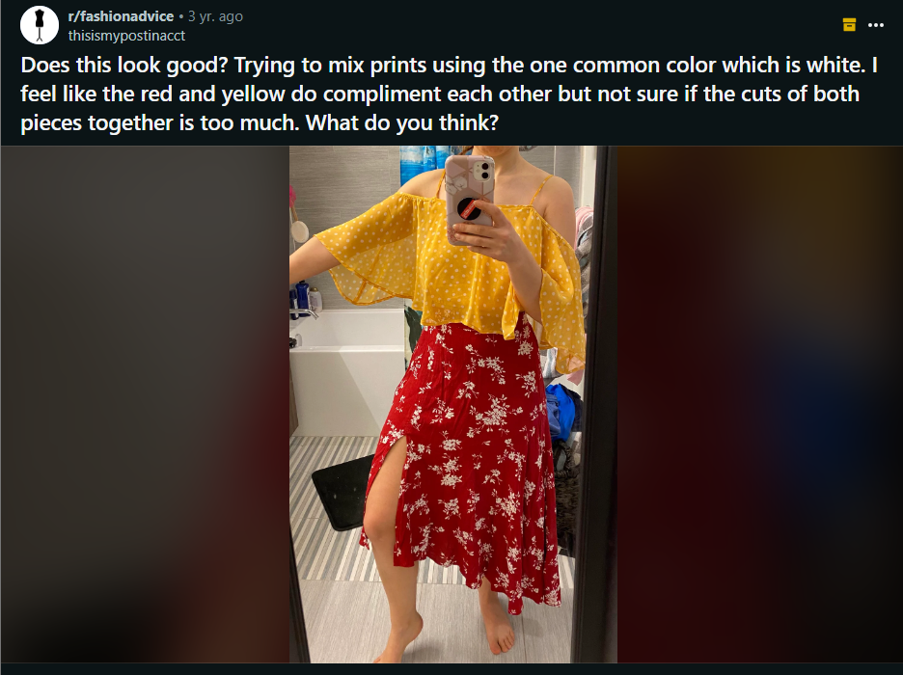

Comments :

1. I think its ALMOST there. If you're mixing prints, I recommend mixing two differently sized prints (ex: top with tiny polka dots, bottom with large flowers)- it creates visual separation
2. I do like the cuts. Typically I find wearing something flowy on top and bottom gets a bit overwhelming, but it works in this case.\n\nHowever, the red and yellow remind me of mustard and ketchup. That might just be me though. My apartment has a yellow living room and red bathroom, and that\u2019s all I think about now when I see red paired with yellow lol
3. I love the two pieces individually but not together. They are both vibrant and pretty enough to look good with just a simple bottom or top. I would try dark wash or white denim with the yellow top, and a simple knit in black, white, or grey for the skirt.
4. I think there\u2019s a lot going on. The clouds go together well, and the patterns, and the cuts, but all together it\u2019s a bit much.
5. Both prints are equally strong and too dissimilar.  I like the pieces but not together.\n\nThe white doesn't work as a common color because it reads as pinkish on the red skirt.
6. I think the top is a bit too flowy, but I can see it really working! Maybe with a big floppy hat? \nEither way I\u2019m obsessed with this color and print combo.
7. I like it! Though I do feel like something is missing, maybe a white belt to break the two apart? So to speak.
8. This works great for out in the sun, the contrasts are perfect, maybe a little light green somewhere but not lime green
9. I think the colors and the cuts work but not the patterns.  They just don\u2019t look like a cohesive style.\n\nAlso I just really love that skirt
10. My advice is it doesn\u2019t look flattering. I\u2019m all about mixing colors and sometimes patterns but polka dots with flowery prints doesn\u2019t look good. Maybe smaller polka dot with bigger or different color would look okay. \nAlso- the top is flowy and so is the skirt. Maybe iron/steam the skirt? I always prefer my clothes well pressed. \nThat top looks like it would go well with a nice high waisted jeans. Skirt, maybe with a plain white T. \nI don\u2019t like to mix lose/flowy clothes but maybe one is flowy and the other is pants or pencil skirt, something that hugs the other half of the body. All my personal opinions...
11. I really like it and I think they work really well together! A white sneaker would tie it together wonderfully!
12. Yes I am agreeing with others that every bit of it goes together but that alone makes it overwhelming! Man.. it\u2019s just too damn close!!
13. I think u should try to find a bottom pice that is close to yellow or maybe orange. Red and yellow r a bit overwhelming(for me at least.)
14. Add a teal green, purple, or bright blue scarf or maybe some long colorful beaded necklaces!

**Post last 91 (LIne - 906327)**

**URL : <https://i.redd.it/37umlkniesh91.jpg>**

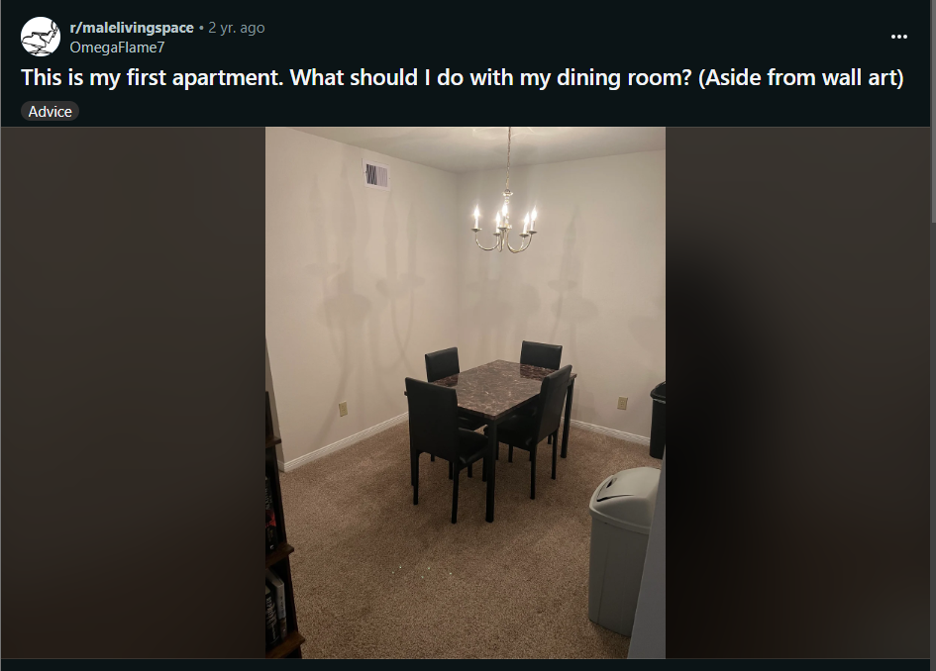

Comments :

1. A couple suggestions: \n1. Move the trashcan out \n2. An area rug with some color to play off the wall art \n3. Change the chandelier out for something more modern
2. You can use a carabiner on the chain link to shorten the length of the chandelier
3. The chandelier bulbs are a bit harsh. A much much warmer tone would help, after all, they are supposed to look like the flame on top of candles
4. I\u2019d actually first recommend to upgrade your both of those trash cans to a stainless steel one and put them in the kitchen. Walmart had them for $55 which is a little pricey for me, but we made the splurge on one and we\u2019ll have it for forever. Game changer. \n\nI\u2019d also recommend a rug, not white, but something to offset the dark furniture. I\u2019d recommend rugsUSA.com , I got one for super cheap for my living room and liked it. Idk if they last long, but for that price and my budget right now it was perfect.\n\nAnd I agree about some wall art, I don\u2019t know your style, but I can picture two large black and white photographs side by side on each wall \n\nGood luck! Can\u2019t wait to see an update
5. A sideboard / buffet / cabinet can be very useful in a dining room and would add more visual interest to the room.
6. Like a one that\u2019s not too wide along the wall? That could double as a wine/alcohol display
7. At least one more trash can
8. rug - someone will spill or drop some food that will destroy that carpet. much easier to take a rug to get cleaned somewhere or just replace the rug if its really bad.
9. I think getting some height would help create some dynamics! So like tall but shallow bookshelves. Maybe 2-3.
10. I wonder if you could place a stylized paper lantern around that chandelier?
11. Are you using this area much for actual dinning? If so, perhaps think about getting a bigger table, and place it perpendicular, so short side to other wall, it seems from the photo that there is enough space.\n\nBigger table and wall art will fill space more and feel cozier. \n\nSorry you can\u2019t do anything about chandelier, it really looks not good, perhaps you can add something to defuse light a little, maybe different lightbulbs, harsh shadows make this space look unwelcoming.\n\nAlso maybe it\u2019s photos wight balance, but for dining area it\u2019s better to have warmer light.
12. Gat a cute cabinet
13. Peel and stick wallpaper!
14. an area rug, permanent place setting (fake flowers, place mats), and maybe a small dresser/barcart on the wall without the trashcan.
15. Area rug for sure.  \n\nBar cart or buffet table. \n\nWall art.  \n\nFake floor plant maybe (lack of windows would make real plants not too ideal) \n\nTable decoration. (candle holders, small plant, etc)
16. vacuum
17. Get a buffet table / sideboard with storage. Then hang a large painting to create a focal point. Remove the trash cans. Add a plant and a candle / fruit bowl.

**Post last 92 (LIne - 905943)**

**URL : <https://i.redd.it/sqobuwlr1gx21.jpg>**

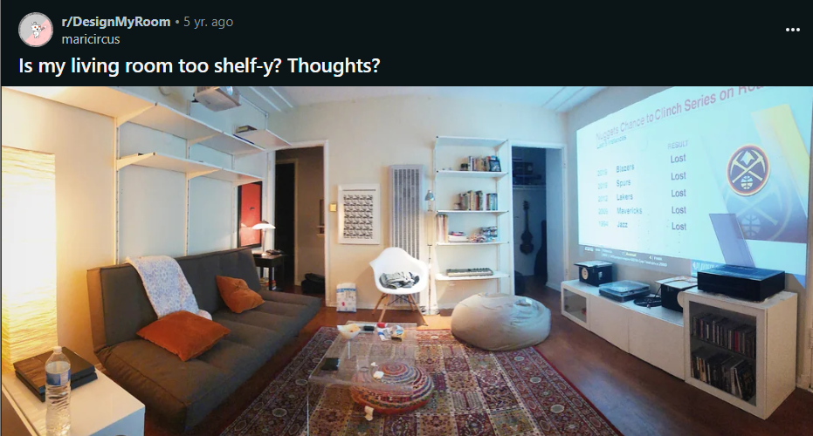

Comments :

1. Maybe a bit - tbh I would remove the shelf behind the couch and hang a big framed poster or a big macramee wall hanger there.
2. Agree. Besides the shelf behind the couch, not too shelfy and super pretty room!
3. If you had them full of books it might look pretty cool.
4. I think it would look nice to swap the white ladder bookcase for a nice natural walnut ladder bookcase.
5. I agree, I think it's more the white shelves that are kind of offputting, not how many there are
6. Yeah i have those ikea shelves and they\u2019re ugly af. They\u2019re intended for an open storage system in a closet or something - not the living room. I would definitely get rid of them
7. I think it looks great, but of course I\u2019ll be the one to say it.... you need to line those shelves with plants!!!!!
8. As another user said, I think if you had the shelves full of books it would look really neat.
9. How about pull the couch out couple feet into the room and put shelves all the way down. A library wall. Couch either pushed back up to the shelves  or pulled out far enough to walk behind it.
10. You either need fewer shelves, or more stuff (books, plants, ***some*** knick knacks). I've never liked this style of shelf, but that may just be me.\n\nDarker shelves might look nicer as some have said. Lot of white here
11. Your room has a chill, but fresh vibe. I agree with those who say greenery on shelves and books, etc.  The shelves add architecture, and create a cozy spot for your sofa.
12. I like it, but you need some plants in there! Will give a pop of color and texture too\nYou could even put little succulents on the shelves as well.
13. Definitely hit up a peddlers mall or goodwill for books to add to the shelves, also plants would fill them in really nicely. I think the shelves above the couch make it look kind of cramped (even though I\u2019m sure there\u2019s enough head room) id at least get rid of the one on the bottom since it doesn\u2019t look like it\u2019s used as much. This room has a super comfy vibe though I think a tapestry or macrame wall hanging would look really good like other people have said:)
14. It needs a big pothos on the top shelf

**Post last 93 (Line - 905534)**

**URL : <https://i.redd.it/k2xn2izp9qu31.jpg>**

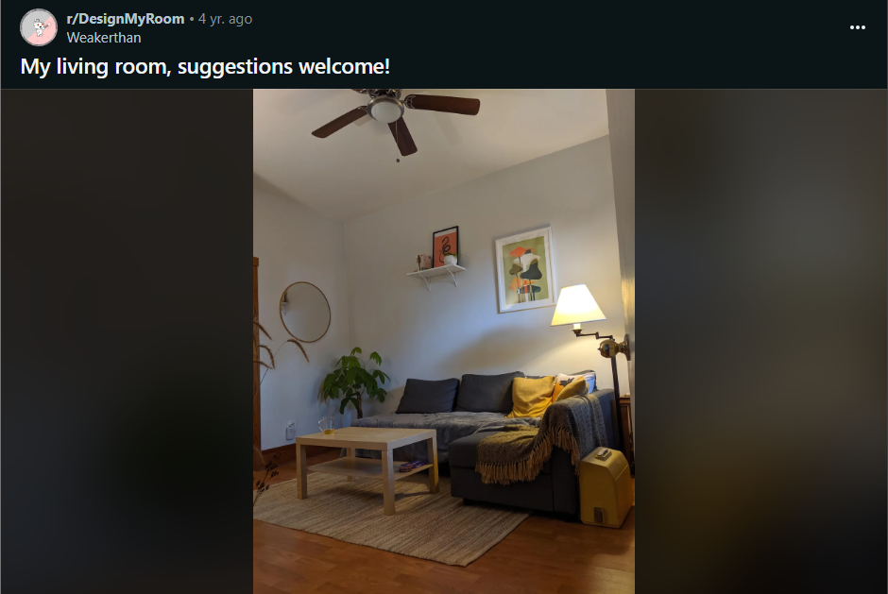

Comments :

1. I like your space! Cozy and nice colours and textures. \n\nI would add another wider shelf below the smaller one OR move that little shelf and picture down a bit, I feel they are up too high.\n\nMaybe a little console table under the mirror.
2. Because it\u2019s a smaller space, I would go with 1 really big framed art behind the couch and see how you like it. I\u2019d take down the shelf.
3. Id take down the shelf aswell. But get more smaller pieces and arrange them in a nice randomish bundle. So you can have more things you enjoy looking at without cluttering all of your walls
4. I'd do larger art frame on the right hand side and move the current pic to under the floating shelf.\n\nthe floating shelf looks a little high too, consider lowering it so the two sides look more balanced.
5. I\u2019ve found that hanging items so the center is at eye-level makes a big difference. I just finished a wall with floating shelves and art. I\u2019m not home to send a picture but if you\u2019d like to message me to remind me, I can send it your way. I had the same issue but think I came up with a good solution.
6. Look up the 57-inch rule for hanging art.
7. Look up the 57-inch rule for hanging art.
8. Hanging plants! Cute space btw
9. Looks great! Could use either a cat or a dog.
10. Hang all wall decor the same distance from the floor. No matter the hight or size the bottom of each picture, self, mirror etc., should be level with each other by measure the same number of inches from the floor. It makes them more congruent.
11. The rug could stand to be larger, but what I\u2019ve found is the large ones are so expensive! So I layer rugs! It adds texture and fun without the expense.\n\nSo my suggestion is get a rug in a pattern you love and layer it.
12. Move the couch to the left, along back 2 walls to improve the flow feng shui of the space.\n\nPut the plant on the right and get a few smaller potted plants, maybe succulents in pots that match your colors. Get some big cream colored bright throw pillows.

**Post last 94 (Line - 905245)**

**URL : <https://i.redd.it/qpfkxhe7csw81.jpg>**



Comments :

1. Honestly none of this. I would buy one in the classical pattern instead or something in color
2. from someone who is still young and maybe my opinion isn\u2019t super valuable: the bag on the right is still pretty bold (id say the silhouette is classic, but the logo is still pretty flashy// and the bag is not what i would consider to be a \u201cclassic\u201d\u2014maybe more so than the one on the left, but probably not a classic piece).\n\nare u certain the bags are going to hold up for 40 years? bags don\u2019t rlly last that long + keep in pristine condition if u actually use them. and tbh, it kinda sounds like you already kinda prefer the bag on the left?? esp since you\u2019d rather a bag not \u201cage\u201d you. if you find that in 10+ years u don\u2019t like it anymore, u can sell and move on tbh, and you\u2019d still get a some worth out of the bag.\n\nalso out of curiosity, does the bag on the left have the cute edgy detailing on the other side? if it doesn\u2019t, then the black side is prob rlly similar to the front side of the right bag.
3. Left. In 40 yrs, you can remove the wallet and chain to make it more age appropriate if it bothers you \ud83d\ude0a
4. If longevity is important to you, then maybe consider the materials as well. Epi leather (left) is known for being durable and hiding imperfections. The leather of the bag on the right is essentially embossed, and the print will wear down over time/with use. \n\nI actually prefer the bag on the left if you\u2019re going for timeless. I personally feel that the larger monogram is more of-the-moment, whereas the bag on the left will remain in style for much longer.
5. Hi, i'm in my mid 20s, I like the one on the right. However, since you know them, you should be able to tell which suits their personal style better. I see the reason why other's like the left but for chicness and minimalism I prefer the right. Like imagine it with a black leather trench coat and boots on top of a block colour or all white ensemble.
6. Left is classy, understated and versatile- I\u2019d go with that one! I wouldn\u2019t worry about how it\u2019ll be perceived in 40 years because it\u2019s impossible to speculate. Go with the one that\u2019ll serve you in the next decade!
7. Beautiful empriente, but the shapes are too old.
8. The one on the left, I would definitely purchase that one.
9. Neither but I love the monogram on the right. If it\u2019s not too flashy for your workplace I\u2019d go with a OnTheGo MM rather than this one.
10. You seem to be looking for versatility. The one on the left would be the better choice in that case.
11. Personally I like the one on the left! I think its quite suited for people of all ages, since its a classic understated work bag. I would remove the white pouch though, feel like the white pouch makes the whole bag looks older and the colour contrast is just not working for me.
12. If these are the two i would do the left one for mid-20's.

**Post last 95 (Line - 904868) --> Deleted**

**URL : <https://i.redd.it/dbebw9v3cpp61.jpg>**

**Post last 96 (Line - 904638)**

**URL : <https://i.redd.it/383fi4ntx2e31.jpg>**



Comments :

1. Orange you glad you asked this question? :)
2. Medium to dark blue
3. Grey
4. I think a black and white pattern could be fun but I also like the idea of white or a super light denim.
5. \"Dont fade away\" *wears faded jeans*
6. I always thought the \"white after labor day\" rule was asinine.   A ton of winter fashion is white.  I think grey would be ok, but white would be better.
7. Denim skirts I feel like would look best, especially for such casual tees.
8. I think a black and white pattern skirt would be fun or one of those red plaid skirts would look really cute with this tucked into them.
9. light denim or a b&w gingham skirt would be cute, imo
10. Black.
11. Gray

**Post last 96 (Line - 904422)**

**URL : <https://i.redd.it/3qkvs8y3ril71.jpg>**



Comments :

1. Jeans and converse
2. Nice. With black loafers, blue jeans and a big watch?
3. I think a pleated white skirt with some white sneakers would be cute.
4. Cinch the bottom add bell bottoms and a chunky heel/sneakers
5. Is it right fitted for you or baggy?\n\nIf Baggy, baggy light blue or light brown pants..\n\nIf it\u2019s semi fitted-fitted then skinny jeans would be cool
6. A skirt with this would look really nice
7. Cute jeans, sneakers or converse, laid back hair style and makeup, simple or no jewelry.
8. A skinny jean (ankle length) paired with a slide on mule. Or instead of a slide mule, you could do a plain white sneaker. Not a fancy sneaker (ex: air max) but like a plain simple one.
9. id toss it since its unauthentic with its fake shirt collar and skirt

**Post last 97 (Line - 904116)**

**URL : <https://i.redd.it/zjnanedm74v91.jpg>**

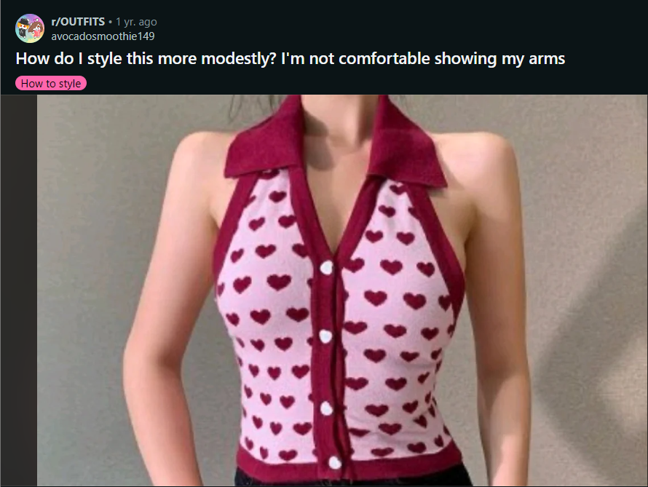

Comments :

1. Maybe a white shirt underneath it
2. Yeah, or a turtleneck for a colder weather.
3. White cardigan and jeans would be super cute. You could also see how it would be as a sweater vest over a button down
4. I would say cropped leather moto, really cute top!
5. I HATE to tell you to put something over this because the collar and pattern are so cute! If I were to wear this I would go one or two routes\u2026 a tighter long sleeved undershirt (white or black is a good start depending on the outfit) or some longer arm warmers! This is adorable and I can\u2019t wait to see what you end up doing :)
6. Maybe get a body suit to wear under?
7. Maybe a cardigan? It gives me pin up vibes so I think that\u2019s a good option.
8. Maybe a lightweight, form fitting shirt underneath? You can really play with the colors and match with any accessories you bring in the mix. I think the classic black or white would look really nice, but maybe some more fun colors like sky blue or lilac would add something
9. Maybe with a shirt underneath in the same color as the pattern,burgundy or white or try to wear it with a jacket
10. White or pink full sleeve body suit?
11. Get a bolero or shrug! I know it\u2019s controversial, but I saw this on SHEIN(links below). Maybe you can screenshot it and find something similar if you prefer to shop elsewhere. I always like to have my shoulders covered so I have a range of cardigans, boleros, shrugs and cover ups. Lol \n\nSHEIN Solid Crop Bolero Shrug Top Without Cami\n\n[URL]\n\nDAZY Solid Lettuce Trim Super Crop Top Without Tube Top\n\n[URL]
12. I would also choose a turtle neck or a white blouse \u263a\ufe0f both will look great and cover you up so you can be comfortable!
13. So cute! Crew neck cardigan all the way. That description will help you find ones that will cover where the sleeves angle in toward the collar, vs a v neck cardigan, which may still show some of that shoulder skin (assuming you prefer not to).
14. I have the same problem omg ! Thank your for asking. Will scroll through the answers lmao
15. A nice structured, long sleeved, white blouse would be perfect underneath! Bonus points if there\u2019s some kind of puff/ruffling at the shoulder of the sleeves. Super cute vest!
16. Probably a red and white striped top underneath
17. No I feel like the red would match but maybe a plain white top too

**Post last 98 (line - 903825)**

**URL : <https://i.redd.it/cbe8tmie08h71.jpg>**

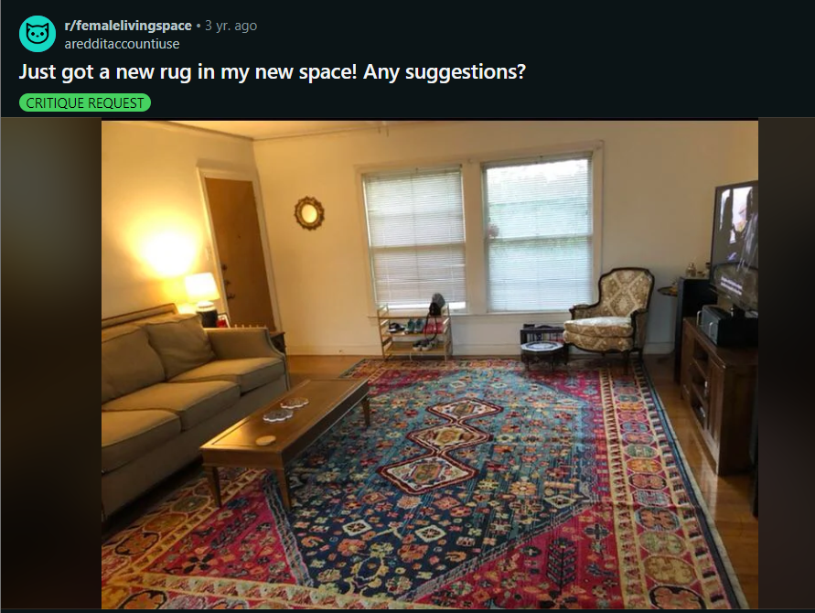

Comments :

1. Looking good so far! I might scoot the couch forward and up on top of the rug a bit. I think the rule is you want to have at least the front legs of a couch on top of a rug to help balance a space. Some big, green plants in a few select locations may also help add extra color and dimension!
2. Before I even read the title I was coming here to say what a nice rug that is! I agree, throw pillows and curtains and wall art that compliment the rug. The chair is a nice piece too!
3. Maybe you could pull your couch away from the wall (where you would walk behind it to go through the room) and putting the chair nearby to one side of the coffee table as if for conversation. Adding plants in the corner where the chair is and some curtains. Of coarse that\u2019s just my opinion and we can\u2019t tell if it\u2019s even a space you need to walk though. You could also put the shoe rack where that lamp currently is and just plants on the floor under your lovely windows. Or you might also consider shifting the whole room sort of on the diagonal with the TV in that corner where the chair is. Just some thoughts. That\u2019s what I would do but then I\u2019m a little odd. Beautiful rug!
4. I love your ideas. The focal point for me becomes the shoe rack because of it\u2019s placement in the window and the natural light draws my eye.\nI\u2019d move it.\nThe idea of creating a more intimate space by pulling the couch away from the wall and close in the seating area will allow moving the shoe rack to where the lamp is and closer to the door. \nI usually keep a separate decorative mat or basket for indoor slides and slippers.
5. Gorgeous rug, but your coffee table looks like its getting devoured by it. I would get a larger coffee table to balance the composition.
6. Light green, orange or blue floor length curtains and throw pillows, a floor length lamp, a Gustav Klimt print above the couch, and a throw blanket on the couch with a color scheme that matches the art. \n\nI like navy blue so I would do blue curtains and throws because the pink and yellows in the carpet are already such a fun pop. But green and orange are complimentary colors of pink and blue respectively so those would be a fun mix of color in the space but I could see it making the space too busy/ less cozy.\n\nEdit: Art ideas: moon goddess by Alphonse mucha, moon goddess hecate art prints on etsy, Reverie by Alphonse Mucha, Hygieia by Gustav Klimt, and maybe a moon phase tapestry in the corner above the chair and LED backlights for the TV because the purple LED behind the TV makes it so much more cinematic.
7. Beautiful rug! Almost exactly what I am looking for myself to have in the future so I am a bit jealous haha. I would buy accent pillows and accent art that follow the theme that the rug has given. Get a real or fake tall plant to put in the corner. Depending on if you\u2019re a minimalist vs a maximalist, play up the decorations little by little. Make it functional for you, but add whatever sparks joy for you. Best of luck, and use photos you find online that you like for inspiration on how to change your space. You have good bones it\u2019s just time for the next few steps. Luckily this is the fun part!\nEdit: also some natural light would do wonders for the neutrals in your space! Imo anyhow
8. I suggest a bigger coffee table or maybe a loveseat or some furniture on the rug
9. Maybe a poster of Nixon bowling
10. A blanket on the couch that matches the blue in the rug

**Post last 99 (Line - 903241)**

**URL : <https://i.redd.it/mq2z9m339hu51.jpg>**

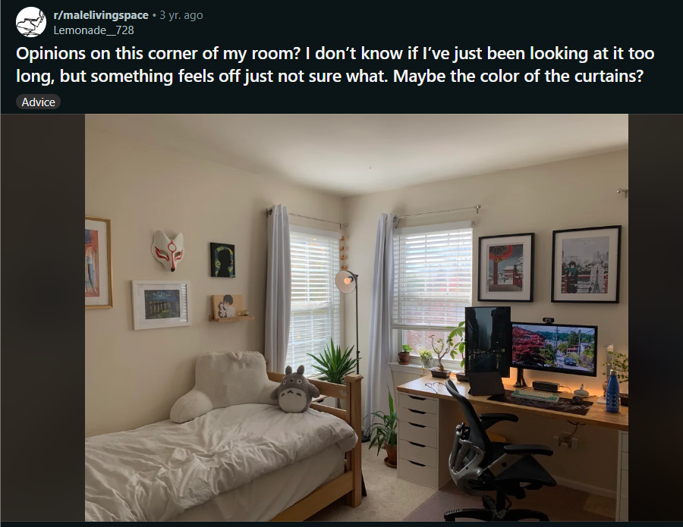

Comments :

1. Don't block access to a perfectly good window. But, you could add two small window benches to form an L. If you cant get sizing right, add a tall stool. Anything to encourage you to use the window. Or if you just want something aesthetically pleasing drop a telescope there.\n\nNever to \"fill up\" a small room. Just increase functionality.
2. I'd go stool. Ottoman is lower to ground and isn't seen my lady guests in the dark. \ud83e\udd19
3. Curtain change is a good idea, also maybe pull the right curtain to the opposite side. Visual weight is on the right, consider swapping the artwork. 2 on the right could be stacked to the left of the windows. 2 smaller pieces could go over the monitor for more balance
4. I think Id leave the space between the windows as is. Maybe the cubes on the left?
5. Maybe a bit bold (use the colour picking app thing you mentioned earlier), but for the curtains you could go for a burnt orange. I say this because the room whilst being very neat and structured looks quite clinical.\n\nThe burnt orange would add a bold colour that would (from how the photos look to me) pick out and tie with the accent colours in some of your art work & your desk top has slight yellow to light orange hues.\n\nWhatever curtain colour you choose I would maybe consider tie backs and create a sweep in your curtains as a focal feature rather than them hanging vertically and thin contrasting with the horizontal blind slats.
6. No. I wouldn\u2019t go burnt orange now.\n\nI originally thought burnt orange just to give a warmth to the room and pull out the colours from your wall pieces like the mask and the \u2018thing\u2019 (can\u2019t think of a better word) hanging off the left window curtain pole and the red from the painting over the monitors, but the rug has those deep reds running through it and adds nice texture. Gray curtains I think would work well. Slate maybe charcoal. Just unsure if I would go for a matte or satin style finish - leaning towards matte as I don\u2019t think shiny material would fit your room.
7. Both seem good colour choices so it would just be a case of overall your personal preference.\n\nIt\u2019s a really nice room though, very light and calm.
8. i would throw a giant bean bag chair in that little nook
9. maybe you could put a small table or bookshelf and put another plant on top? idk, that may be too much
10. Raise the curtains to ceiling,

**Post last 100 (Line - 902798) --> Deleted**

**URL : <https://i.redd.it/72nvfll41ai61.jpg>**